**Assignment 10 Tactile Graphics**

**Keke Wu**

**Description:** In this assignment, I’m translating an image of pie chart for Cognitive Disabilities by Categories in the US into a tactile graphic, the original data was provided by the Coleman Institute for Cognitive Disabilities and the visualization was created by me.

The pie chart was translated into a hand-made origami “Butterfly Chart”, where there were five columns mapped with the five categories, each column was separated by the paper fold and had the number of butterflies based off of the corresponding population.

**Original Image:**

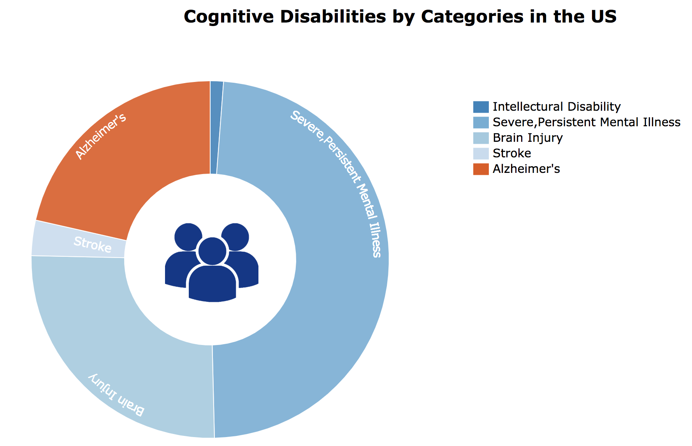

**Learning Outcomes:**

* This chart shows the population of people with cognitive disabilities in the US by categories.
* There are 5 categories in total in this chart.
* There is a “Chart Junk” image at the center of the chart, which is a population clip art.
* People with Severe, Persistent Mental Illness accounts for the most population, while people with Intellectual Disability accounts for the least population.
* People with severe, Persistent Mental Illness accounts for almost 50% of the total population.
* The 5 categories by population are Severe, Persistent Mental Illness, Brain Injury, Alzheimer’s, Stroke, Intellectual Disability.

**Comprehension Questions:**

* How many categories are there in this chart?
* Which category of cognitive disability has the most population? Which has the least?
* Which category has more population, stroke or intellectual disability?

**Results & Takeaway:**

I tested this tactile visualization with two participants and asked them to finish the above questions. After the first round, I polished the experiment as shown on Page2. The first tester found it really hard to tell each category apart from the rest, so I added those folds between each column as separators. The most difficult part of this translation was around the label mapping. Even with only 5 categories, there was still pretty big cognitive load to memorize each category and to locate their position in this graphic. As data scaled, tactile graphics got messy really quick. Without a visual overview of the complete visualization, it took way longer for the testers to answer Q1. The comparison task as in Q3 turned out to be the easiest one to answer as long as the testers found the right spot for each category. While I was crafting this tactile visualization, I found it very tough to translate the accurate proportion of each category. For example, in the original chart, the population with Severe, Persistent Mental Illness accounts for almost 50% of the total population, however, in the tactile translation, I inevitably lost this detail.

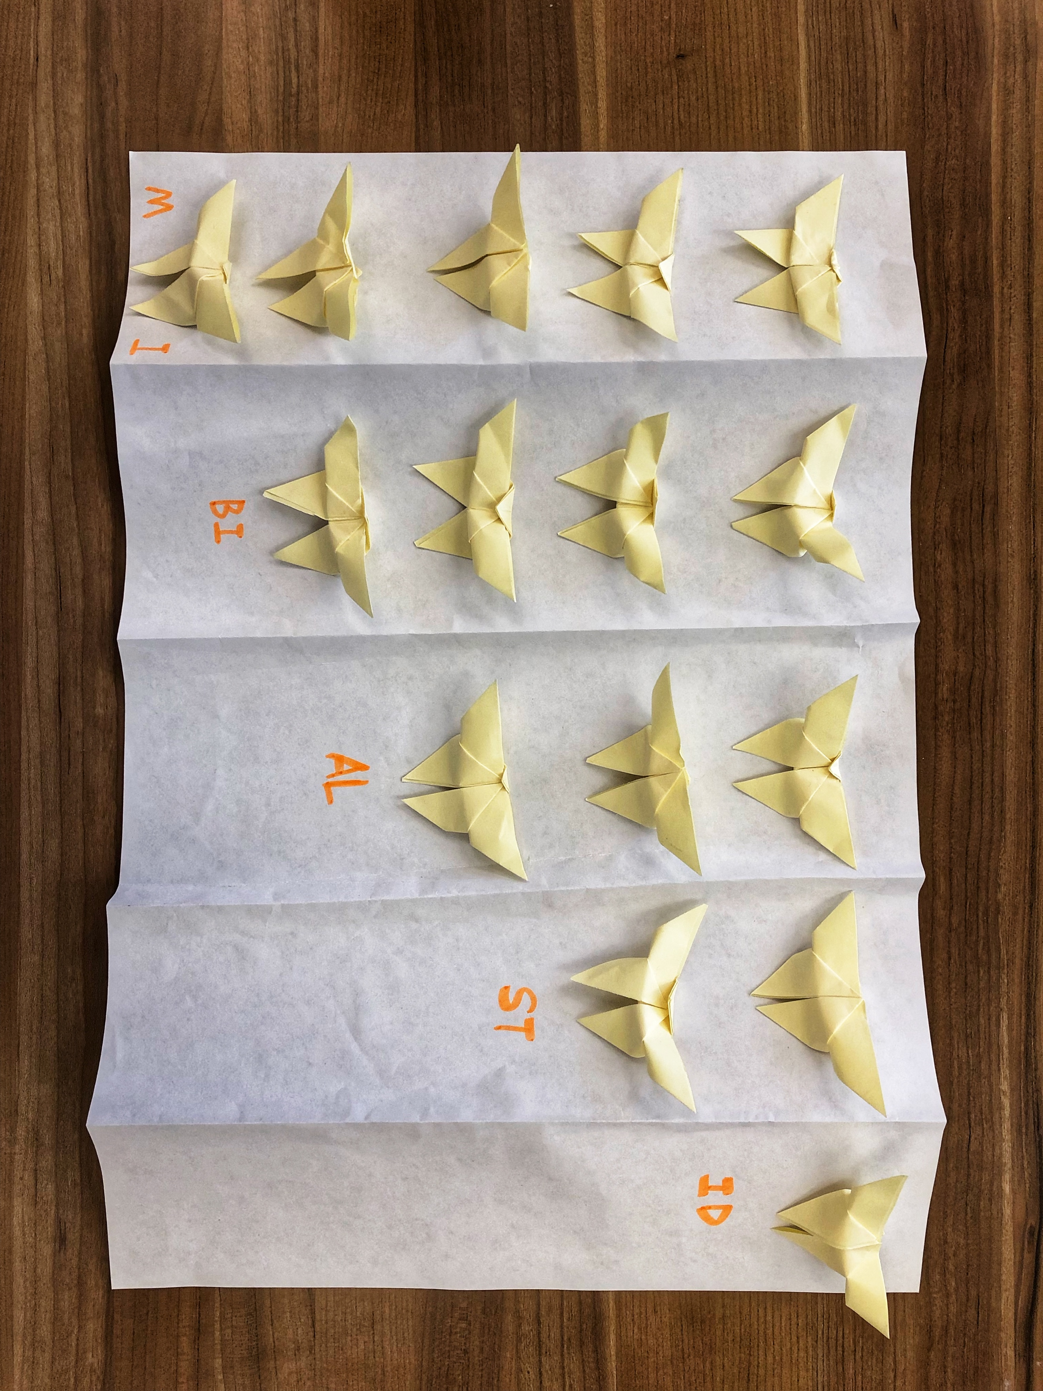

**Tactile Graphic:**

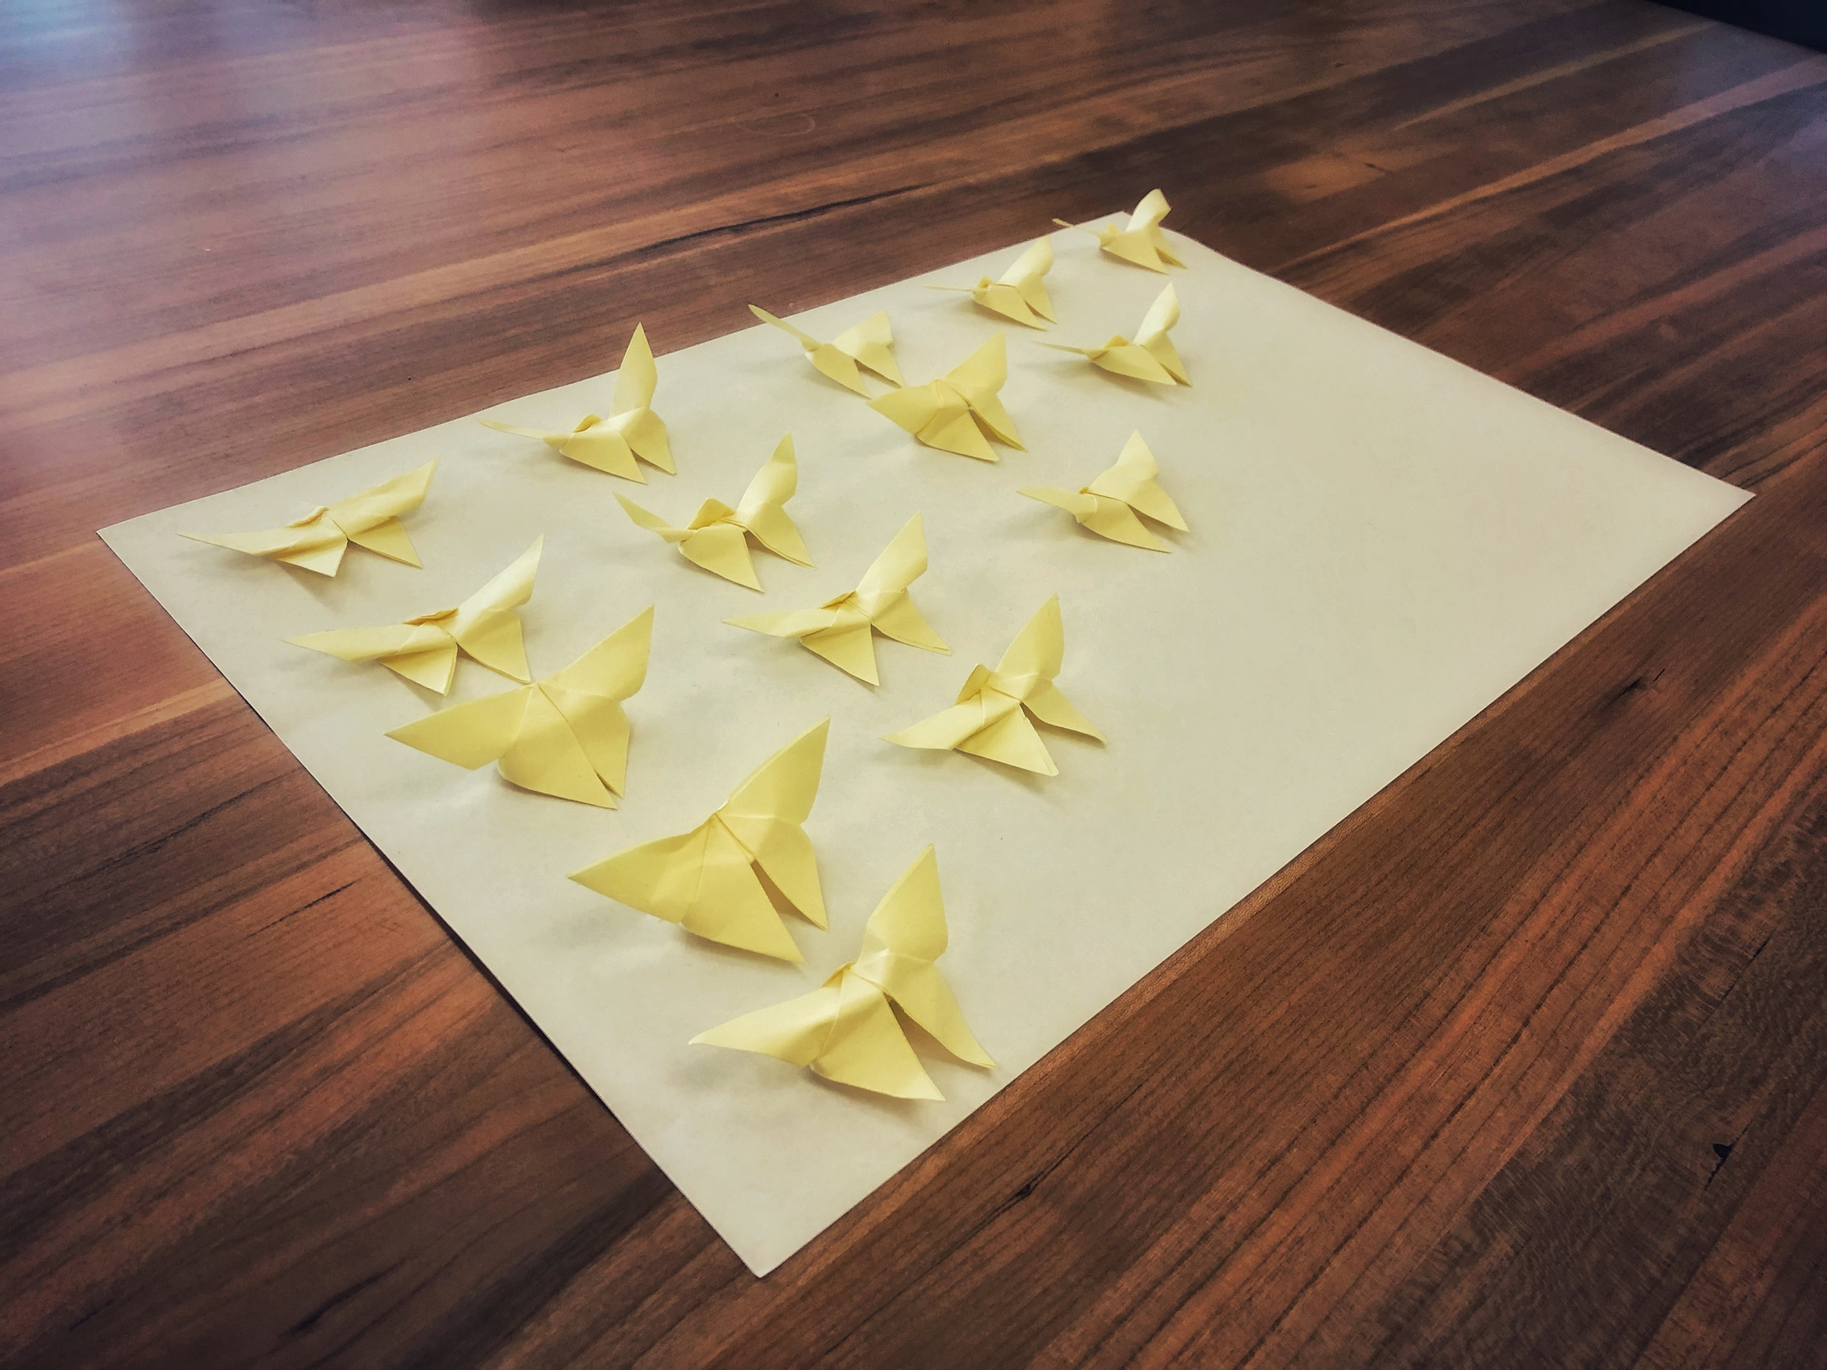

**Version 1: Without folds as separators Version 2: Added folds as separators**